**DAILY ONLINE ACTIVITIES SUMMARY**

|  |  |  |  |  |  |  |  |  |
| --- | --- | --- | --- | --- | --- | --- | --- | --- |
| **Date:** | **06-06-2020** | | | | | **Name:** | **Preethi** | |
| **Sem & Sec** | **6th - B** | | | | | **USN:** | **4AL17CS065** | |
| **Online Test Summary** | | | | | | | | |
| **Subject** | | **Python Application Programming** | | | | | | |
| **Max. Marks** | | **30** | | **Score** | | | **26** | |
| **Certification Course Summary** | | | | | | | | |
| **Course** | **Introduction to Cloud Computing** | | | | | | | |
| **Certificate Provider** | | | **Cognitive Class-IBM**  **DeveloperSkillsNetwork** | | **Duration** | | | **10 hours** |
| **Coding Challenges** | | | | | | | | |
| **Problem Statement:2 Python and 1 C program** | | | | | | | | |
| **Status: executed** | | | | | | | | |
| **Uploaded the report in GitHub** | | | | | **Yes** | | | |
| **If yes Repository name** | | | | | <https://github.com/PreethiNayak/Daily-Status/tree/master/06June2020> | | | |
| **Uploaded the report in slack** | | | | | **Yes** | | | |

Online Test Details: (Attach the snapshot and briefly write the report for the same)

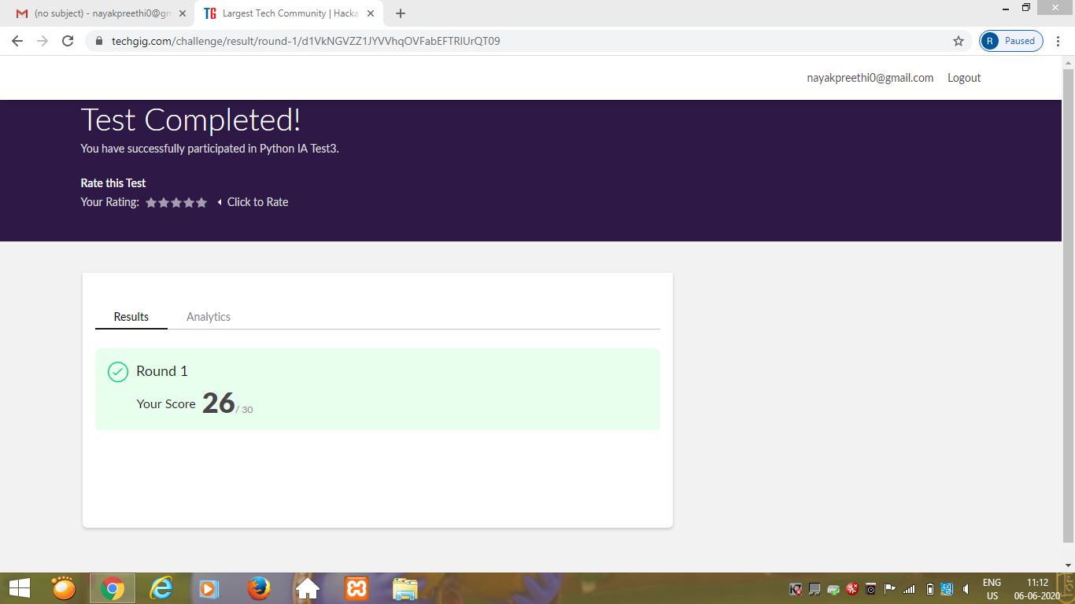

Certification Course Details: (Attach the snapshot and briefly write the report for the same)

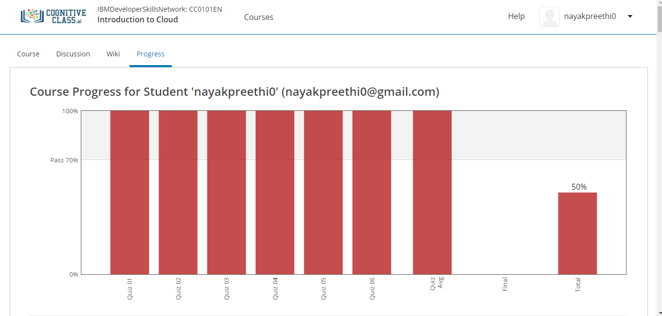

Today I completed module 6 –“Emergent Trends,Cloud Native,DevOps and Application Modernization”

In this I learnt,

1. Hybrid Multicloud.

2.Microsrvices.

3. Serverless Computing.

4.Cloud Native Applications.

5.DevOps on the Cloud.

6. Application Modernization.

Coding Challenges Details: (Attach the snapshot and briefly write the report for the same)

Program 1

This is output of C program to rotate an array by N positions.

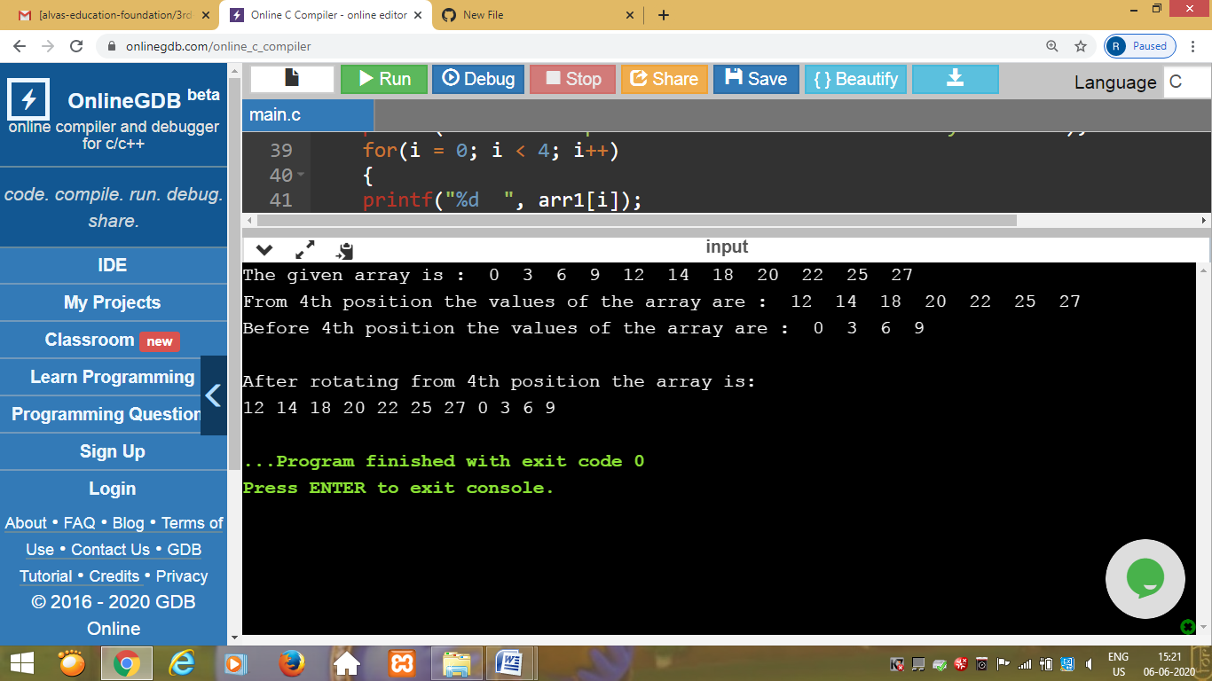

Program 2

This is the output of the python program to perform Cyclic Redundancy Check.

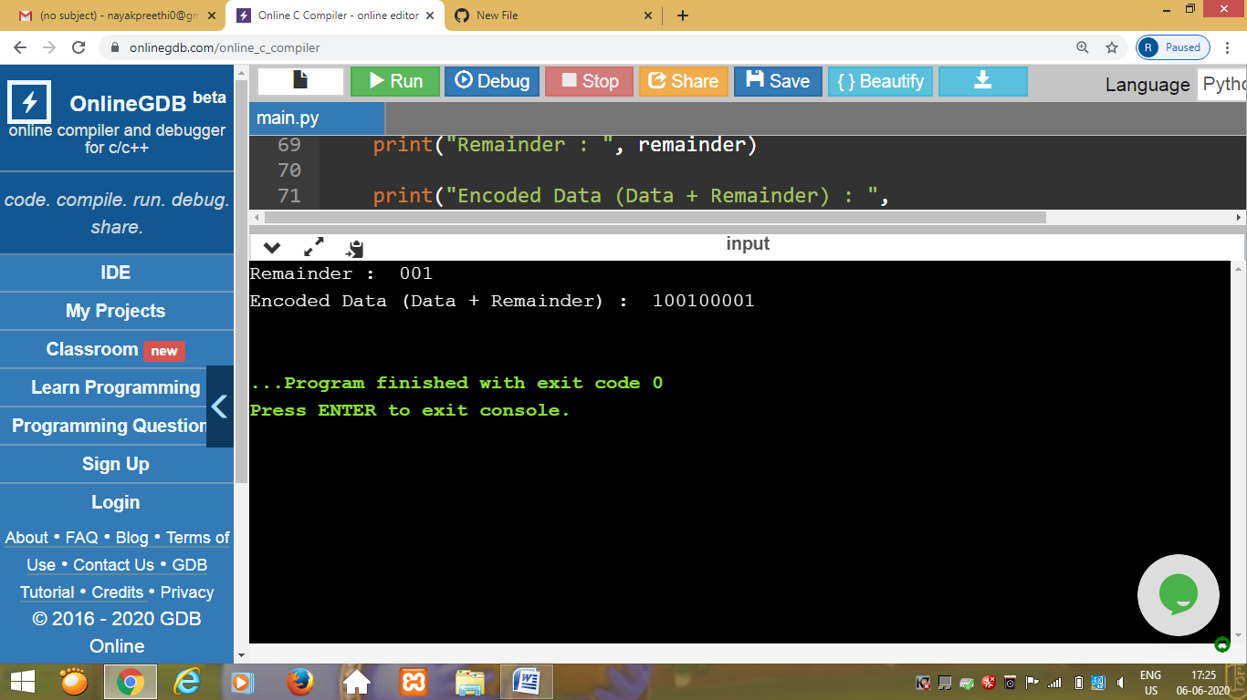

Program3

This is the output of the python program to count the number of strings, provided string length is 2 or more and the first and last character are same from a given list of strings.

